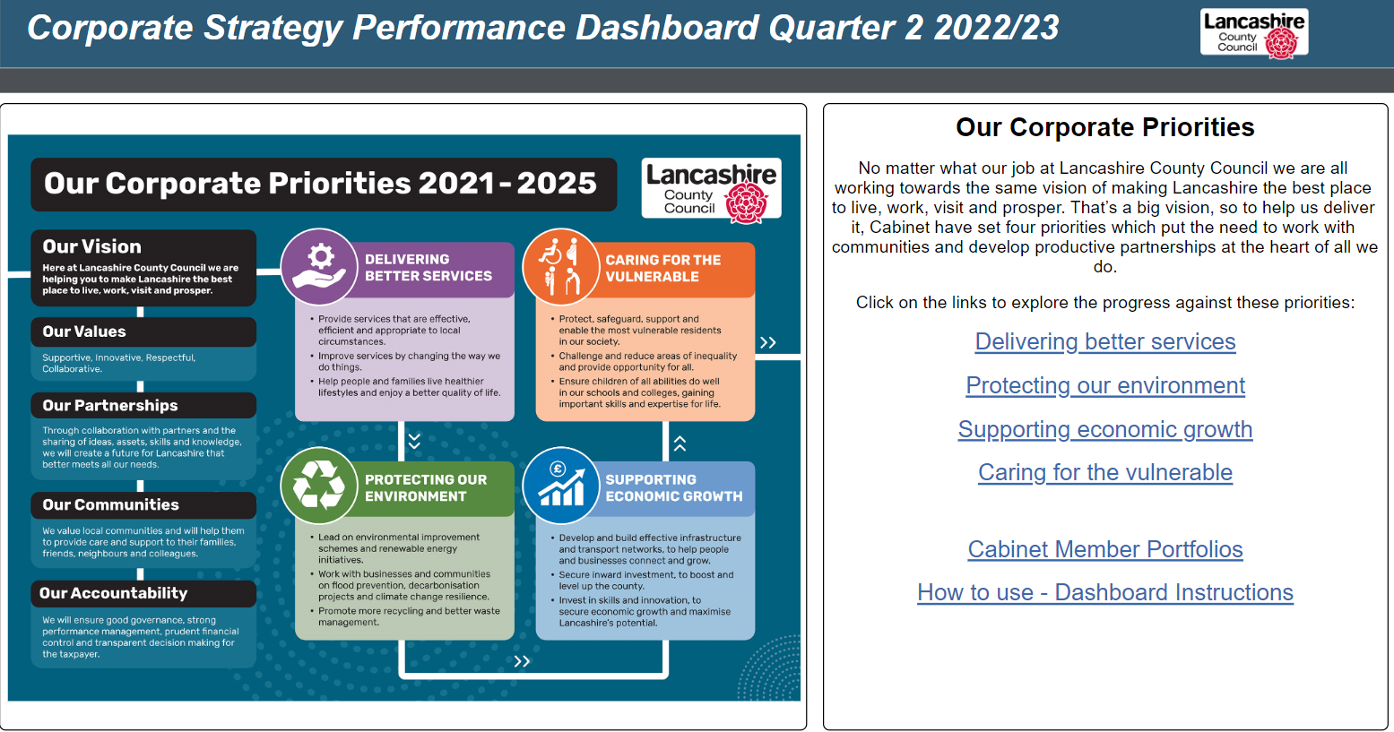
NOTE: instructions on use of the online dashboard can be found on page 2 of this report, or online here
Link to this page online: Home

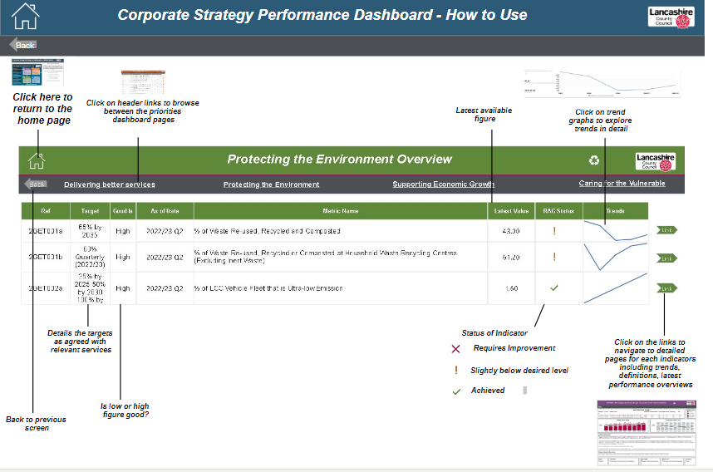
Link to this page online: How to use

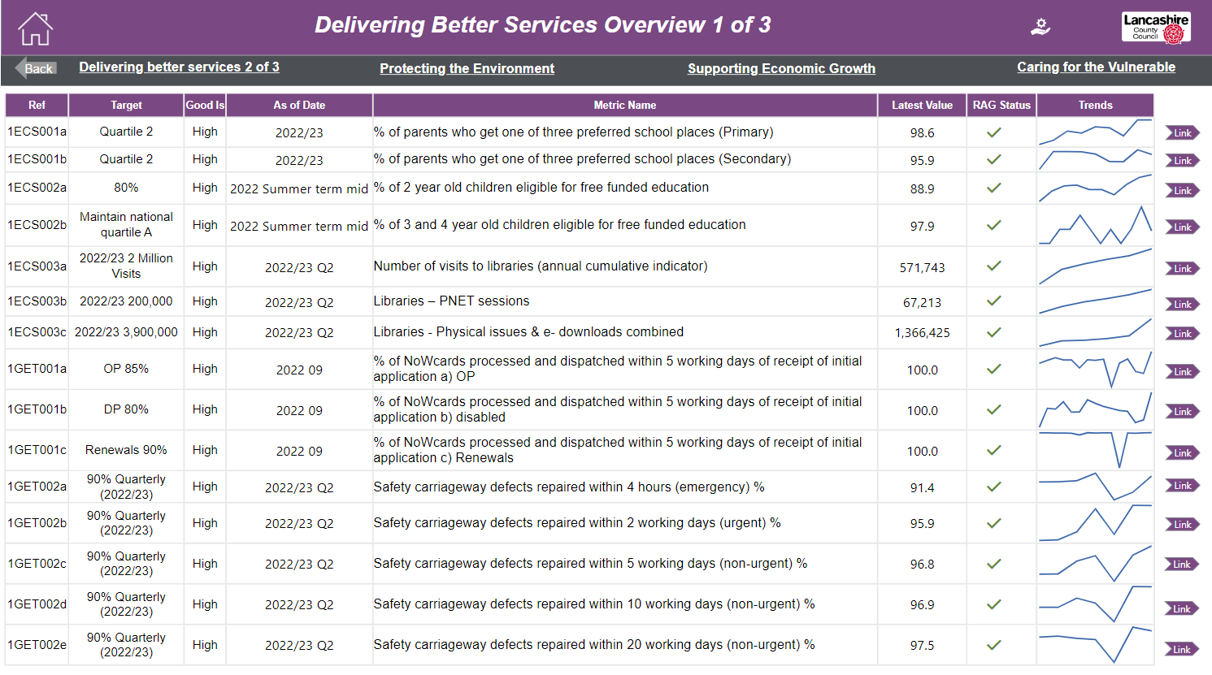
Link to this page online: Delivering Better Services Overview 1 of 3

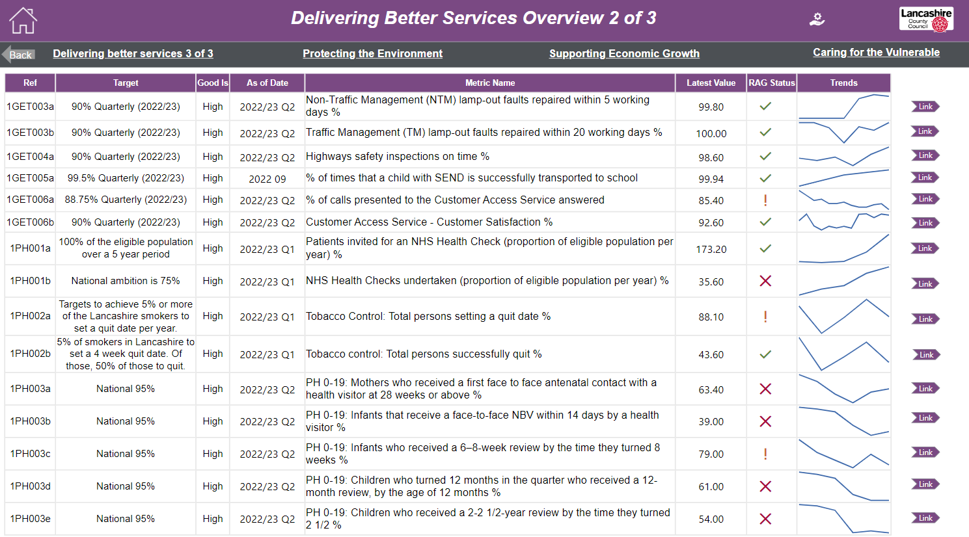
Link to this page online: Delivering Better Services Overview 2 of 3

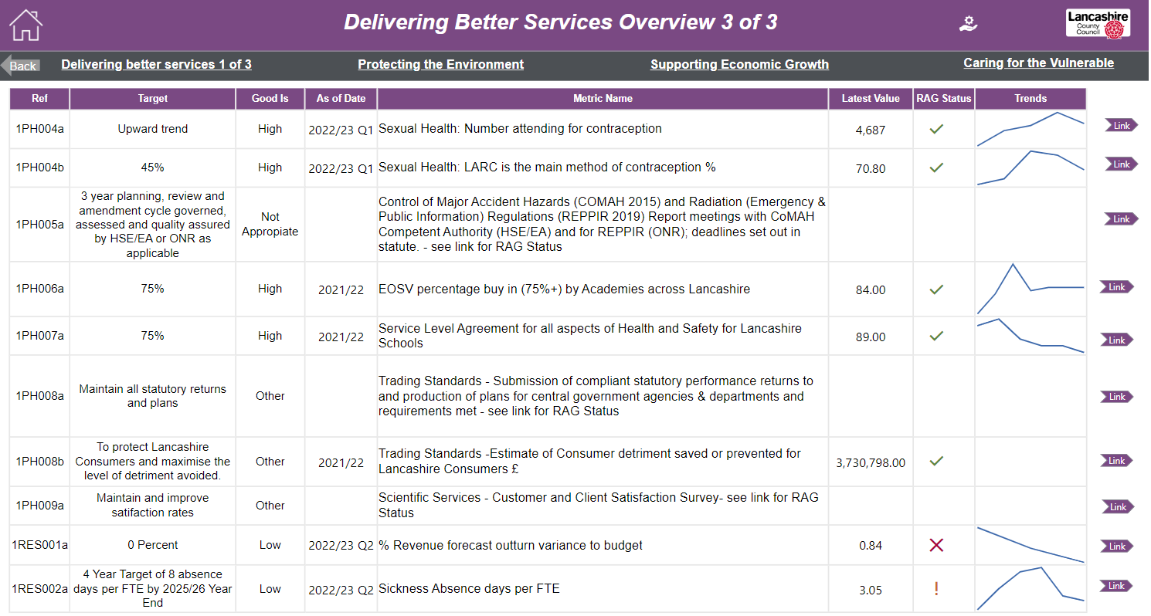

Link to this page online: Delivering Better Services Overview 3 of 3
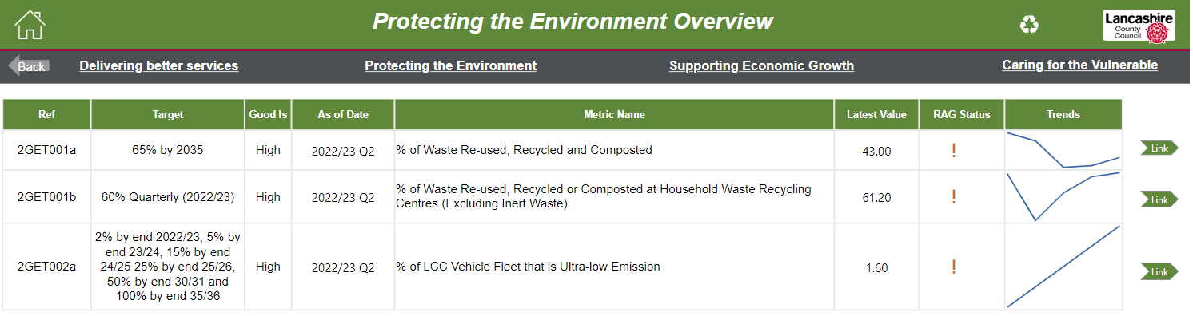

Link to this page online: Protecting the Environment Overview

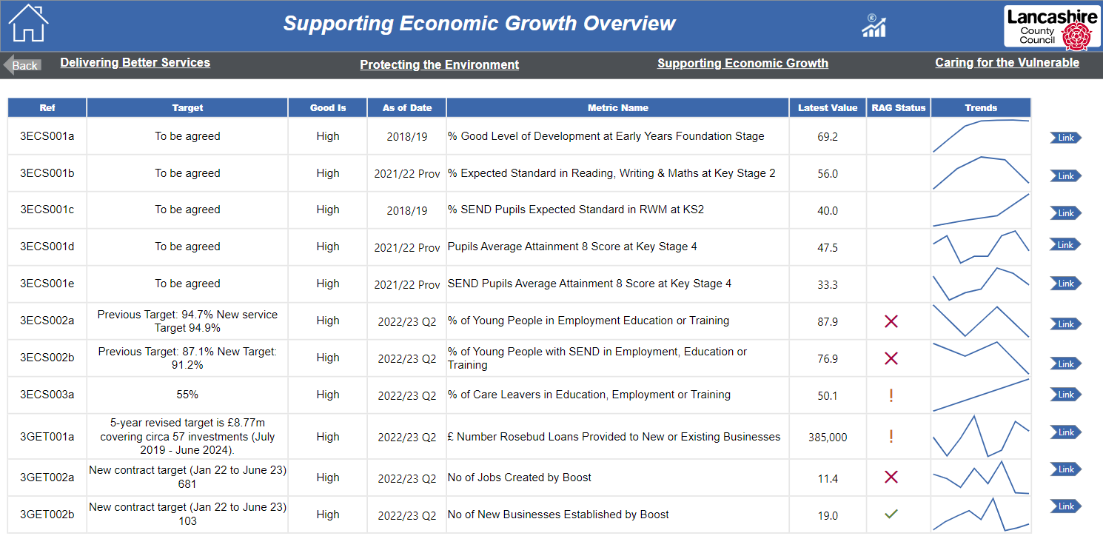

Link to this page online: Supporting Economic Growth Overview

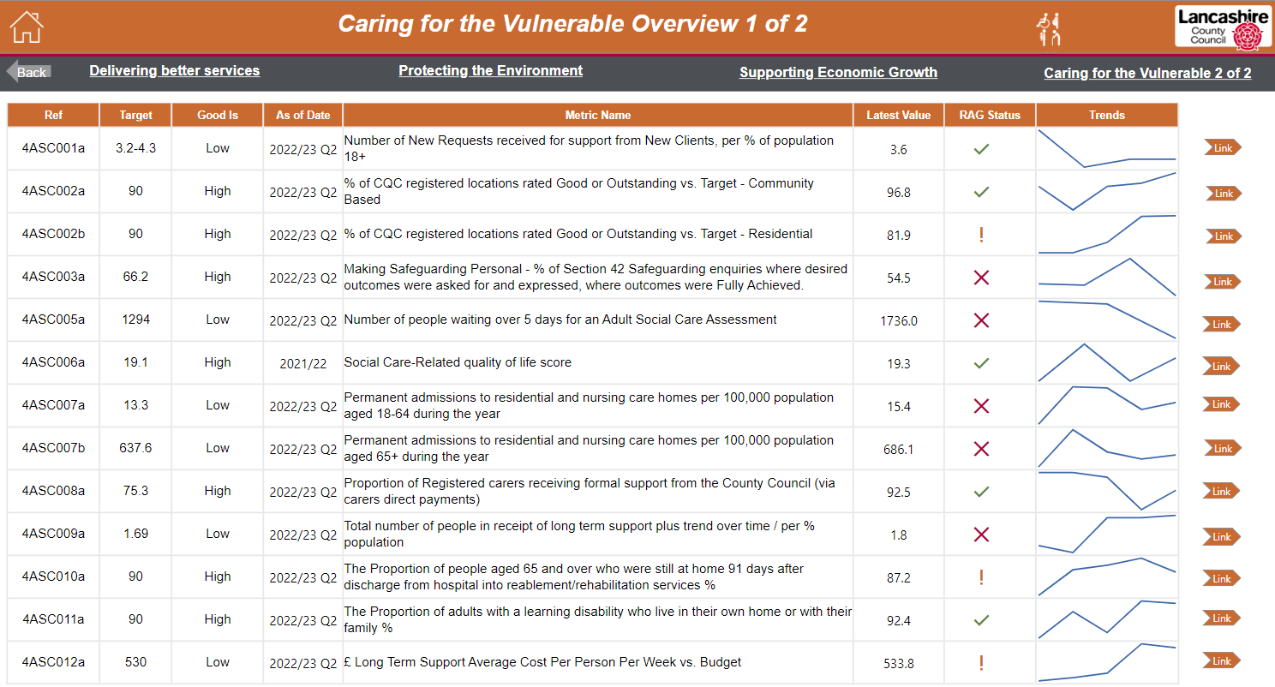

Link to this page online: Caring for the Vulnerable Overview 1 of 2

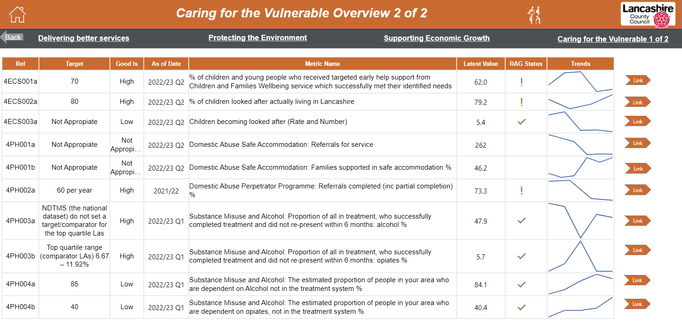

Link to this page online: Caring for the Vulnerable Overview 2 of 2

